The Nexus Point of ASEAN Ways and Eurasianism: An Possible Eclectic Conceptual Framework Towards Resilient Territorial Integration Between ASEAN-EURASIA starting with ASEAN-EEC
Farrel Mukti Attallah, Indonesaia, 21 Years Old
Fakulty of Economics and Business, Universitas Indonesia, Depok, 16424,
West Java – Indonesia
E-mail: farrelmukti23@gmail.com, Mobile Number: +6281225475783

Abstract
This paper proposes an eclectic conceptual framework for fostering resilient territorial integration between ASEAN and the Eurasian Economic Commission (EEC). It explores how diverse diplomatic strategies and theories can create a robust partnership between ASEAN and Eurasia, addressing current gaps in regional integration. The framework integrates the "ASEAN Way" approach and the principles of Eurasianism to develop a multi-dimensional model that encompasses historical and contemporary diplomatic practices, innovative policies, and collaborative strategies. It emphasizes the importance of bridging differences through soft power diplomacy, actor-based and systems-based strategies, and regional learning processes. By focusing on gap analysis, the Unified Integration and Resilience Model, and the concept of a security community, the framework aims to build a sustainable and effective partnership between ASEAN and the EEC. Key components of the framework include the promotion of social capital, inclusive regional learning, and the balance between efficiency and renewal. The proposed model advocates for continuous dialogue, mutual collaboration, and capacity building to achieve a stable and integrated ASEAN-Eurasia relationship, ultimately contributing to regional stability and growth.

Keywords: ASEAN-Eurasia Integration; Diplomatic Framework; Resilience and Stability; Soft Power Diplomacy; Regional Cooperation

Sub-Theme: Innovative Diplomatic Frameworks for Resilient Teritorial Integration

"Factors influencing effective regional cooperation are mindsets and perceptions emanating from the past"
-Khaleda Zia-
INTRODUCTION
ASEAN is an important figure and cannot be underestimated in world geopolitical chess and we can see how the diplomatic thinking framework is used. ASEAN has changed a lot since its founding in 1967, from a forum that primarily focused on regional peace and stability to a multifaceted organization that deals with many things, such as security, economic cooperation, and socio-cultural integration. Over the years, the “ASEAN Way” Approach which is a distinctive approach to regional cooperation and conflict management within the Association of Southeast Asian Nations (ASEAN), characterized by the principles of non-interference, consensus decision-making, and methods Informal and pragmatic relations between countries are a characteristic of ASEAN (Padmakumara, 2021). ASEAN has developed a broad framework consisting of three pillars: political-security, economic, and socio-cultural. The main goal is to resolve conflicts and create a peaceful and stable regional environment that supports economic growth (Dosch & Kliem, 2023). This framework aims to strengthen Southeast Asian identity and meet the needs of all members (Thompson & Sunchindah, 2023). In addition, the organization has attempted to involve non-state parties in regional decision-making. However, this involvement is often limited to the process of legitimizing and maintaining the status quo (Soni, 2023). With inclusive pillars and involvement, ASEAN has the opportunity to collaborate with other global organizations to expand regional integration
Furthermore, one of the interesting integration potentials for ASEAN is the Eurasian Economic Commission. The Eurasian Economic Union (EAEU) was founded in 2015 to support the economic integration of its member states, including Russia, Belarus, Kazakhstan, Armenia, and Kyrgyzstan, and the Eurasian Economic Commission (EEC) plays an important role. The ideology of Eurasianism has become a regional characteristic of Eurasia. Eurasianism is an ideology emphasizing Eurasia's unique cultural and geopolitical identity that has significantly influenced the formation and development of the Eurasian Economic Union (EAEU) (Bazavluk et al., 2022). The EAEU, founded as a political and economic integration project, embodies many of the socio-political ideas of Eurasianism, aiming to create a multipolar world order and counterbalance Western influence. Despite its efforts, the EEC faces major problems in promoting regional integration through a comprehensive policy framework. The EEC's strategy to eliminate non-tariff barriers has attracted the attention of business associations in the region (Braun et al., 2023a). These are the main trends observed. However, member states have hindered deeper integration due to their reluctance to grant substantial powers to the EEC and their attempts to limit cooperation on economic issues (Braun et al., 2023a). This essay aims to implement innovative integrative policies to find ASEAN and EEC nexus points that lead to resilient territorial integration in the ASEAN-EURASIA context. The benefits are the ability to recover from negative impacts, adapt to external pressures, and the ability to push the limits of creativity.

THE MAIN BODY
The electic concept is a concept that is suitable for formulating a framework of thinking in realizing resilient territorial interaction between ASEAN and the EEC. In various fields, the concept of eclecticism denotes the integration and application of various ideas, theories, and techniques to solve complex problems. Eclecticism in architecture is defined as a design concept that combines important elements such as Pluralism, Historicity, Elitism, Decoration, Innovation and Symbolism. This allows for a comprehensive and nuanced design approach that reflects contemporary cultural differences and interpretations (Cheng & Neisch, 2022). The author believes this concept can be applied in the context of regional integration. Adaptation of ideas from one field to another is scientifically proven to have many advantages, as it increases innovation and efficiency (Manchado-Pérez et al., 2018).
The framework that the author initiated involves several parts such as Gap analysis, Unified Integration and Resilience Model, actors, and facilitators.
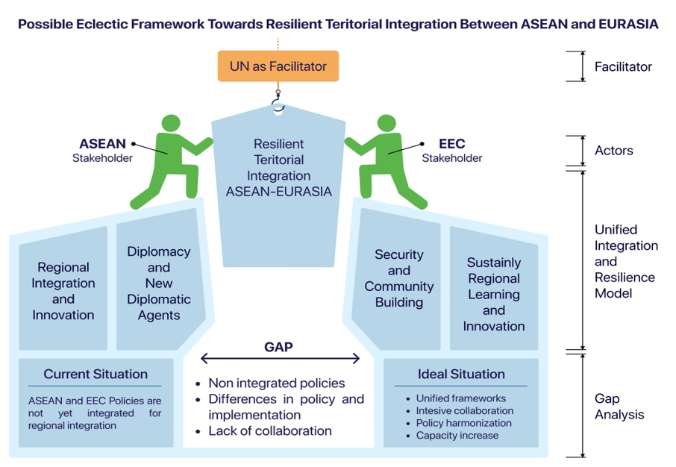
Figure 1. Eclectic Conceptual Framework Towards Resilient Territorial Integration Between ASEAN-EURASIA starting with ASEAN-EEC. Source: Author's eclectic formulation
Gap Analysis Starts in the Current Situation where ASEAN and EEC do not yet have an integrated framework for regional integration. Even though ASEAN has established diplomatic relations with the EAEU (Fedorov, 2020). Then the existing gap revolves around how to create a resilient territorial integration framework between ASEAN and the EEC. The ideal situation expected is an integrated framework, intensive collaboration, policy harmonization, and capacity building. The gap analysis framework is proven to be a highly effective tool in a variety of fields, providing a structured methodology for discovering and addressing discrepancies between the current state and desired outcomes (Ramirez-Villegas et al., 2020).
The Unified Integration and Resilience Model starts from regional integration and innovation. Here the concept that the author raises is the new diplomatic agenda. the emergence of a "new diplomacy" characterized by the participation of small states and non-governmental organizations (NGOs) in international agreements, as seen in the creation of the International Criminal Court (ICC) and the Ottawa Process for the ban of land mines. This method has challenged conventional power dynamics and introduced new approaches into diplomatic practice (Davenport, 2002).
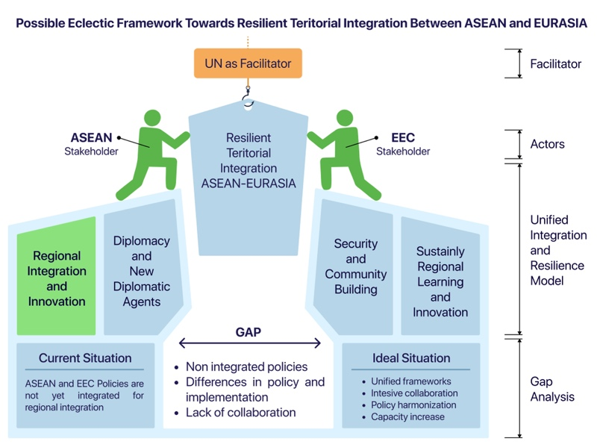
Figure 2. Source: Author's eclectic formulation
China and other countries have used soft power effectively, such as through esports and language and cultural education. This is a lesson for ASEAN-EEC where soft power diplomacy is something important, especially for the modern era approach. Scandinavian countries, such as Sweden, Norway and Denmark, prioritize dialogue, negotiation and the search for joint solutions in international relations. Additionally they are committed to democracy, human rights, and sustainability (Cherkasov, 2022). The Triple Helix model in Scandinavia also emphasizes collaboration between universities, industry and government as the key to creating an innovative environment (Ekman et al., 2011). The Scandinavian model of diplomacy reflects the broader values ​​of these countries and ASEAN-EEC can learn from it.
Then we need to pay attention and strategy to new diplomacy agents. This concept can be started from the concept of plutocracy which is like a two-edged sword. “Rule by the rich”, or plutocracy, is a term of Greek origin meaning “rule by the rich”, referring to a type of society in which the rich have a significant role in economic and political decision-making (Varghese, 2021 ). Plutocracy has many dangers. This increases income inequality, which is increasing between the top 1% and the rest of society, especially in English-speaking Western countries. This wealth and power undermines democracy by limiting political influence and opportunities for the majority, resulting in social and economic inequality (Green, 2016). Understanding plutocratic bias in economic measures such as the Consumer Price Index (CPI), improving education, and promoting a more equitable distribution of wealth are some strategies to reduce its impact (Castillo et al., 2000).
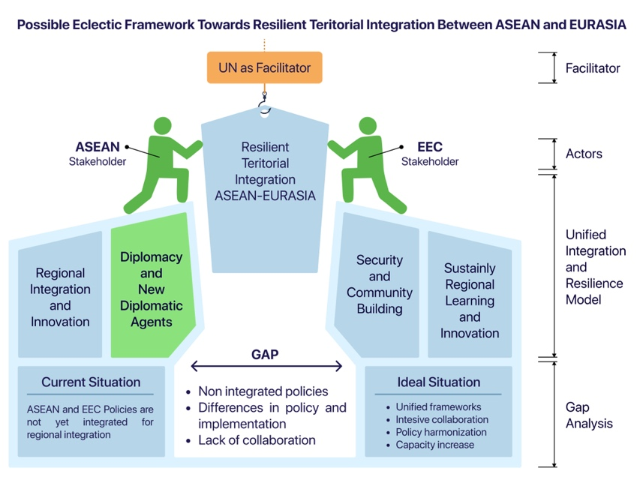
Figure 3. Source: Author's eclectic formulation
Actor-based strategies and systems-based strategies in the Regional Innovation System (RIS) work together to encourage sustainable regional economic growth and the development of new pathways. Actor-based strategies focus on increasing the innovation capacity of individual entities such as entrepreneurs, which is an important factor in increasing economic competitiveness (Tödtling et al., 2021). On the other hand, a systems-based strategy aims to improve the overall RIS function by increasing the RIS capacity to develop new channels and increase economic competitiveness (Isaksen et al., 2022). Paying attention to which RIS ASEAN-EEC uses is crucial to creating output that meets needs.
The most crucial concept in this essay is in this paragraph. To build resilient ASEAN-EURASIA territorial integration, the first concept is optimizing social capital. Social capital in the form of a network of relationships, social norms, trust and support in a society. Social capital plays a role in resilient territories by promoting collaboration, facilitating knowledge sharing, and fostering social cohesion.
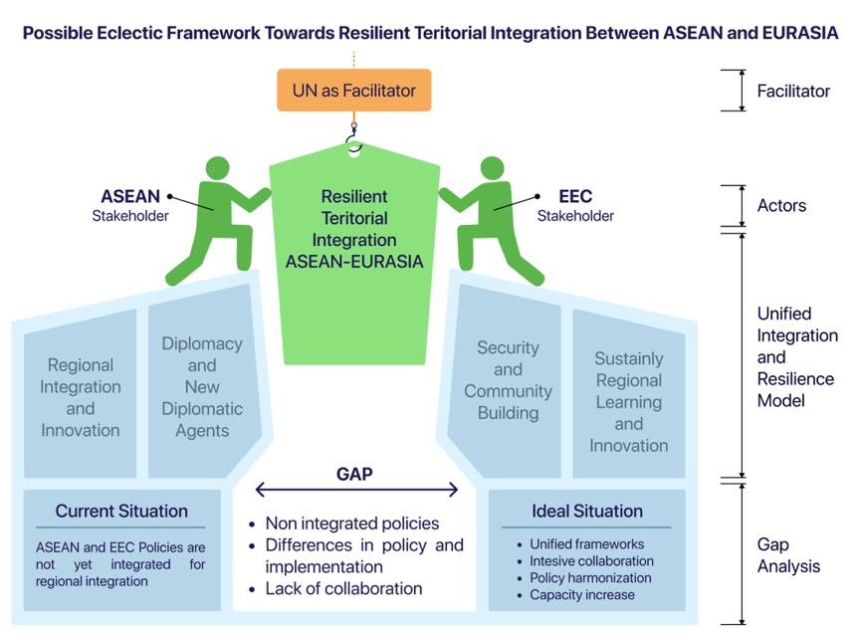
Figure 4. Source: Author's eclectic formulation
Then further, we need to pay attention to the Cluster evolutionary phases which start from emergence, growth, maturity, and decline or transformation (Pinto, 2015). This model is important for making ASEAN-EEC development decisions. ASEAN is currently at the growth stage towards maturity, with rapid increases in investment and infrastructure (Putri & Ann, 2022), even though it faces the challenge of development gaps between member countries. On the other hand, the Eurasian region, including the countries in the Eurasian Economic Union, is at the emergence stage towards growth with great potential but still requires investment and closer cooperation (Braun et al., 2023b). Then the concept of dualism between efficiency and renewal is important in political and business contexts (Simonin et al., 2023). The balance between these two concepts is important to create ASEAN-EEC resilience which will later lead to territorial integration between ASEAN-EURASIA.
Security and Community Building then become building blocks in realizing territorial resilience. The concept of security community refers to a condition in which a group of countries has stable and peaceful relations among themselves, with a shared belief that armed conflict between members will not occur.
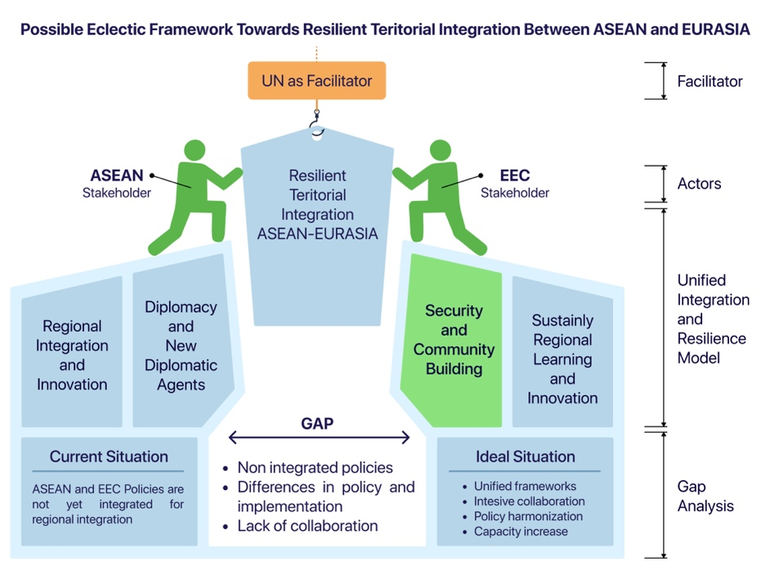
Figure 4. Source: Author's eclectic formulation
security community involves intersubjective factors such as norms, socialization processes, and collective identity formation, apart from material factors (Acharya, 2001). In the ASEAN-EEC context, we can encourage the above factors to be applied in development diplomacy. This is important to do.
The next building blocks are Sustaining Regional learning and innovation. The concept of inclusive regional learning highlights the importance of including various elements in the regional learning process to achieve equality, diversity and justice. Important elements that need to be included include gender equality, work-life balance, community involvement, and equality of access.
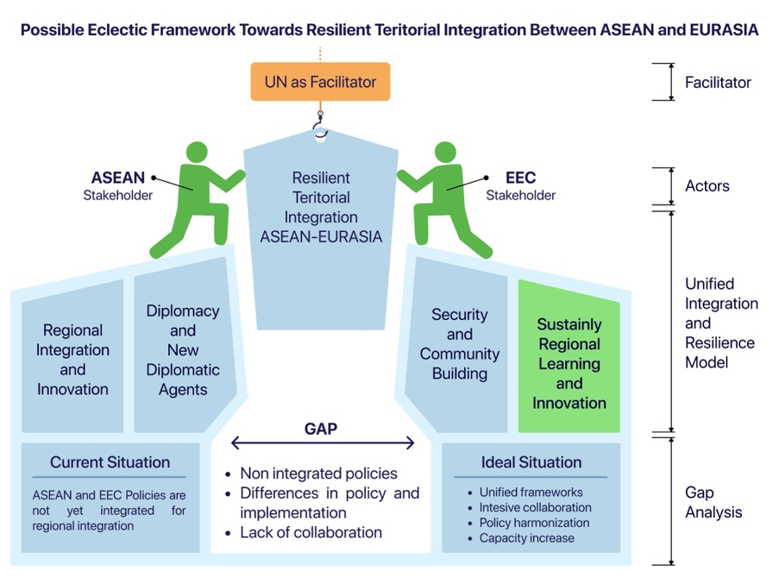
Figure 5. Source: Author's eclectic formulation
Next, we need Recentering Regional Learning, where this concept highlights the need to shift regional learning centers from a dominant masculine perspective to a more inclusive and diverse direction. This aims to create a more balanced, fair and sustainable learning environment by accommodating the contributions of all parties, including women, in the regional innovation and learning process. Masculine case studies in this context refer to research that tends to be dominated by male perspectives, so recentering regional learning emphasizes the importance of taking into account gender issues, work-life balance, and community involvement in regional learning to achieve broader inclusivity (James, 2017) . This needs to be considered so that ASEAN-EEC continues to carry out regional learning exponentially.
Then the actors and facilitators ultimately determine the extent to which ASEAN-EEC is integrated. Actors consisting of ASEAN-EEC play a crucial role in playing every building block in the framework that the author has built. Two-way collaboration helps ensure that the most important building blocks in the form of territorial resilience can close gaps and create bridges to territorial integration. The facilitator in the form of the United Nation is also no less important. By supporting regional development strategies that align with the Sustainable Development Goals (SDGs), the United Nations plays an important role in promoting territorial integration.
Another innovation in this essay to support resilient territorial integration is the sustainable multi-track diplomacy framework. This framework is an innovation of the multi-track diplomacy framework which adds a spiral element which indicates continuous diplomacy, then there is a diplomacy stage, and there is capacity building.
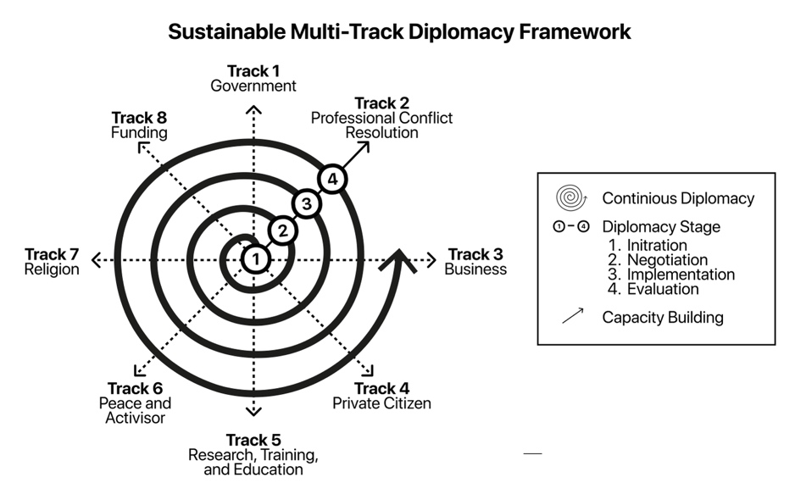
Figure 6. Sustainable Multi-Track Diplomacy Framework. Source: Author's formulation

The author hopes that the design will be a catalyst for resilient territorial integration between ASEAN and Eurasia starting from ASEAN-EEC.
CONCLUSIONS
The proposed eclectic conceptual framework for ASEAN-Eurasia integration emphasizes a multi-dimensional approach that leverages diverse strategies and theories to foster resilient territorial cooperation. By addressing gaps through unified integration models and innovative diplomacy, the framework envisions a harmonious and effective partnership between ASEAN and the Eurasian Economic Commission (EEC). This approach incorporates elements from historical and modern diplomatic practices, soft power strategies, and actor-based and systems-based methodologies to build a robust foundation for regional stability and growth. Through continuous dialogue, collaboration, and capacity building, the framework aims to bridge differences and enhance the resilience of ASEAN-Eurasia territorial integration.

REFERENCE
Acharya, A. (2001). Constructing a Security Community in Southeast Asia. Routledge.
Balão, S. M. R., & Silva, T. de A. e. (2022). Diplomacy in the Context of Political Science, International Relations and Strategic Studies (pp. 15–37). https://doi.org/10.1007/978-3-030-81877-7_2
Bazavluk, S. V., Kurylev, K. P., & Savin, L. V. (2022). Eurasianism, Eurasian Economic Union and Multipolarity: Assessments of Foreign Experts. Vestnik RUDN. International Relations, 22(1), 30–42. https://doi.org/10.22363/2313-0660-2022-22-1-30-42
Braun, M., Gromilova, A., & Melnikovová, L. (2023a). Understanding Economic Integration in the Eurasian Economic Union – the Relevance of Integration Theories. Journal of Contemporary European Studies, 1–14. https://doi.org/10.1080/14782804.2023.2193877
Braun, M., Gromilova, A., & Melnikovová, L. (2023b). Understanding Economic Integration in the Eurasian Economic Union – the Relevance of Integration Theories. Journal of Contemporary European Studies, 1–14. https://doi.org/10.1080/14782804.2023.2193877
Castillo, J. R., Ley, E., & Izquierdo, M. (2000). The Plutocratic Bias in the CPI : Evidence from Spain. IMF Working Papers, 167, 1. https://doi.org/10.5089/9781451858174.001
Cheng, K. L., & Neisch, P. (2022). A new perspective on eclectic attributes in architecture: taking eclectic architecture in Beijing and Hong Kong as an example. Journal of Asian Architecture and Building Engineering, 22(3), 1126–1145. https://doi.org/10.1080/13467581.2022.2074017
Cherkasov, A. (2022). Scandinavian Welfare Model and its Features. Vestnik Universiteta Imeni O. E. Kutafina, 9, 122–130. https://doi.org/10.17803/2311-5998.2022.97.9.122-130
Chunyan, L. (2022). The World of Mind: Category and Planning (pp. 31–39). https://doi.org/10.1007/978-981-19-3057-7_3
Davenport, D. (2002). The New Diplomacy. Policy Review, 17.
Dosch, J., & Kliem, F. (2023). The Association of Southeast Asian Nations: an introduction. In The Elgar Companion to ASEAN (pp. 1–15). Edward Elgar Publishing. https://doi.org/10.4337/9781800378889.00007
Ekman, M., Gustavsen, B., Asheim, B. T., & Pålshaugen, Ø. (2011). Learning Regional Innovation: Scandinavian Models. Palgrave Macmillan.
Fedorov, N. V. (2020). “External Contour” of Eurasian Integration: Cooperation Between the EAEU and the ASEAN (pp. 251–272). https://doi.org/10.4018/978-1-7998-1950-9.CH014
Florkowska, L., & Bryt-Nitarska, I. (2018). The requirements for implementing Sustainable Development Goals (SDGs) and for planning and implementing Integrated Territorial Investments (ITI) in mining areas. E3S Web of Conferences, 36. https://doi.org/10.1051/e3sconf/20183601004
Gautam, G. (2022). Implications of Geopolitics in International Diplomacy. 8(1), 38–42. https://doi.org/10.3126/hisan.v8i1.53066
Green, J. E. (2016). Liberalism and the Problem of Plutocracy. Constellations, 23(1), 84–95. https://doi.org/10.1111/1467-8675.12147
Isaksen, A., Trippl, M., & Mayer, H. (2022). Regional innovation systems in an era of grand societal challenges: reorientation versus transformation. European Planning Studies, 30(11), 2125–2138. https://doi.org/10.1080/09654313.2022.2084226
James, Alison. (2017). Work-Life Advantage : Sustaining Regional Learning and Innovation. John Wiley & Sons, Incorporated.
Manchado-Pérez, E., López-Forniés, I., & Berges-Muro, L. (2018). Value of Adaptation of Methodologies Between Different Knowledge Areas: As Applied in the Context of Project-Based Learning (pp. 221–248). https://doi.org/10.4018/978-1-5225-5279-6.CH010
Padmakumara, S. C. (2021). A Conceptual Analysis on ‘ASEAN Way’ as a Normative Approach for Conducting Regional Affairs. 6(1), 1. https://doi.org/10.4038/CJMR.V6I1.58
Pinto, H. (2015). Resilient Territories: Innovation and Creativity for New Modes of Regional Development. Cambridge Scholar Publishing.
Putri, N. S., & Ann, D. (2022). Eria contribution to development of asean infrastructure through comprehensive asian development plan (cadp). Sociae Polites, 23(2), 16–29. https://doi.org/10.33541/sp.v23i2.4151
Ramirez-Villegas, J., Ramirez-Villegas, J., Khoury, C. K., Khoury, C. K., Khoury, C. K., Achicanoy, H. A., Mendez, A. C., Diaz, M. V., Sosa, C. C., Debouck, D. G., Kehel, Z., & Guarino, L. (2020). A gap analysis modelling framework to prioritize collecting for ex situ conservation of crop landraces. Diversity and Distributions, 26(6), 730–742. https://doi.org/10.1111/DDI.13046
Simonin, J., Waldeck, R., & Puentes, J. (2023). A dual perspective of organizational resilience (OR) and information technology systems resilience (ITSR): an analysis of interdependencies and tensions. ARPHA Conference Abstracts, 6. https://doi.org/10.3897/aca.6.e107704
Soni, J. (2023). ASEAN - a case of illiberal regional democracy (pp. 108–121). https://doi.org/10.4337/9781800378889.00015
Thompson, E., & Sunchindah, A. (2023). An ASEAN identity. In ELGAR Companion to ASEAN (pp. 49–61). Edward Elgar Publishing. https://doi.org/10.4337/9781800378889.00011
Tödtling, F., Trippl, M., & Desch, V. (2021). New directions for RIS studies and policies in the face of grand societal challenges. European Planning Studies, 1–18. https://doi.org/10.1080/09654313.2021.1951177
Varghese, M. (2021). Plutonomy: The New Financialized World Order (pp. 55–60). https://doi.org/10.1007/978-981-15-9263-8_9

APPENDIX
Curriculum Vitae


